Kinematics Review Quiz Multiple Choice Questions

1. Two hikers set out from the same spot and arrive at the same destination but they take different routes. Which of the following quantities must be the same for both hikers?
a. | distance | d. | displacement
b. | average speed | e. | acceleration
c. | average velocity

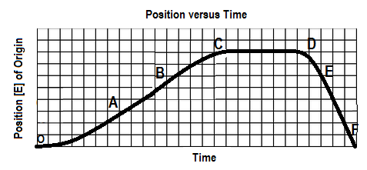
2. The graph below shows a position-time graph

Over which interval is the object moving west and speeding up?
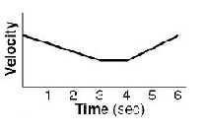
a. OA b. BC c.CD d. DE e.EF

3. A velocity-time graph is shown at right. Which of following best
describes the object’s motion? The object

a. moves backward at a constant velocity, stops, then moves forward at constant velocity.
b. moves forward at a constant velocity, stops, then moves backward at constant velocity
c. slows down uniformly as it moves backward, stops, then speeds up uniformly as it moves forward
d. slows down uniformly as it moves backward, continues at a constant velocity backward, then speeds
up uniformly as it moves forward
e. slows down uniformly as it moves forward, continues at a constant velocity forward, then speeds up
uniformly as it continues to move forward

4. Which of the following graph(s) does(do) NOT represent uniform motion?
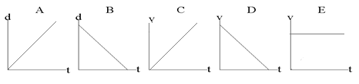

a. | A,B,C and D | d. | A and B
b. | B only | e. | C and D
c. | E only

5. Which of the following are VECTOR quantities?
I. position II. speed III. displacement IV. velocity
a. I and III only d. II, III and IV only
b. III and IV only e. I, III and IV only
c. I and IV only

SPH4U0 Kinematics Review Quest Name:_________________

Useful Equations:
v_{av} =ΔΔ a =ΔΔ = Δ Δd= ½ (v₁+v₂) Δt Δd=v₂ Δt – ½ a (Δt)²

Δd=v₁ Δt + ½ a (Δt)² Δd = $\frac{v22-v12}{2a}$
Total: _________/35 marks [K/U]

Part A: Multiple Choice Answers [ 5 marks]:
Write the letter representing the best answer for each question in the table below:
1 | 2 | 3 | 4 | 5

Part B: Short Answer [ 5 marks]:

- Anmol tells Manroop that an object that has negative acceleration must be slowing down. Explain whether Anmol’s statement is correct. Give an example to support your answer. [3]

2. Explain the difference between average velocity and instantaneous velocity. Provide an example to illustrate the difference. [2]

Part B: Graph Analysis [10 marks]

1. The motion of a train engine moving along a straight track in a railyard is shown on the velocity-time
graph below.
- Describe the motion in the space below [2]
ii) Draw the corresponding acceleration-time graph for the train. [2]
iii) Assuming that the train starts at the station (origin), draw the corresponding
position-time graph. [6]

Velocity-Time Graph:
8

4

0

-4

-8

V
(m/s)

[E]
 |  |  |  |  |  | B
 | A |  |  |  |  |  |  |  |  |  |  | C
Time
(s)
 | 2 4 6 8 10 12 14
 |  |  |  |  |  |  |  |  |  |  |  |  |  |  |  |  | D

Motion Description: [2]

A:

B:

C:

D:

Graph Calculations:

Acceleration-Time Graph:

Position-Time Graph:

Part C: Problem Solving [15 marks]

- Sukhman throws a cricket ball up in the air with an initial velocity of 6.5 m/s [up]
Determine:
- How high the ball will rise [2]
- The time it takes for the ball to reach its maximum height [2]

- A police car is at rest at a stop light when a speeding Kunj passes the police car at a constant
velocity of 25.0 m/s [F]. As the Kunj passes by, the police car turns on its siren and accelerates at a rate of 3.5 m/s² [F] in hot pursuit after a 2s delay! Determine the time required for the police car to catch the Kunj and the displacement from the stop light at which the police car catches up. [6]

- One day while Tragan is out for a drive, travelling at a constant velocity of 70 km/h [E], he approaches an intersection 50 m away. The light changes to red and he reacts by applying the brakes after a 200.0 ms delay. Once he begins to brake, he comes to a stop after 4.7 seconds. Does Tragan stop in time for the intersection ahead or does she run the red light? [5]

